🏥 Healthcare Insurance Cost Dashboard
📊 Project Overview
This project analyzes healthcare insurance data to identify key factors affecting medical costs. An interactive dashboard was built in Excel using PivotTables, charts, and slicers to provide insights into customer risk and cost drivers.
Objectives
- Understand factors influencing insurance charges
- Identify high-risk customer segments
- Build an interactive dashboard for data exploration
Dataset
- Source: Insurance dataset (CSV format)
- Records: 1,338 customers
- Features:
  - Age
  - Sex
  - BMI
  - Number of children
  - Smoker status
  - Region
  - Charges
Data Processing
Created additional features to improve analysis:
- BMI Category (Underweight, Normal, Overweight, Obese)
- Age Band (18–25, 26–35, etc.)
- High Risk Flag (Smoker + Obese)
Dashboard Features
- KPI Metrics:
  - Total Customers
  - Average Charges
  - Median Charges
  - Smoker %
  - High Risk %
- Visualizations:
  - Charges by Smoker
  - Charges by BMI Category
  - Charges by Age Band
  - Charges by Region
  - High Risk Distribution
- Interactive slicers for filtering data
Key Insights
- Smokers have significantly higher insurance charges than non-smokers
- Obese individuals tend to incur higher medical costs
- Insurance charges increase with age
- High-risk customers (smoker + obese) form a small but critical segment
Tools Used
- Microsoft Excel
  - PivotTables
  - PivotCharts
  - Slicers
  - Calculated Fields

Dashboard Preview
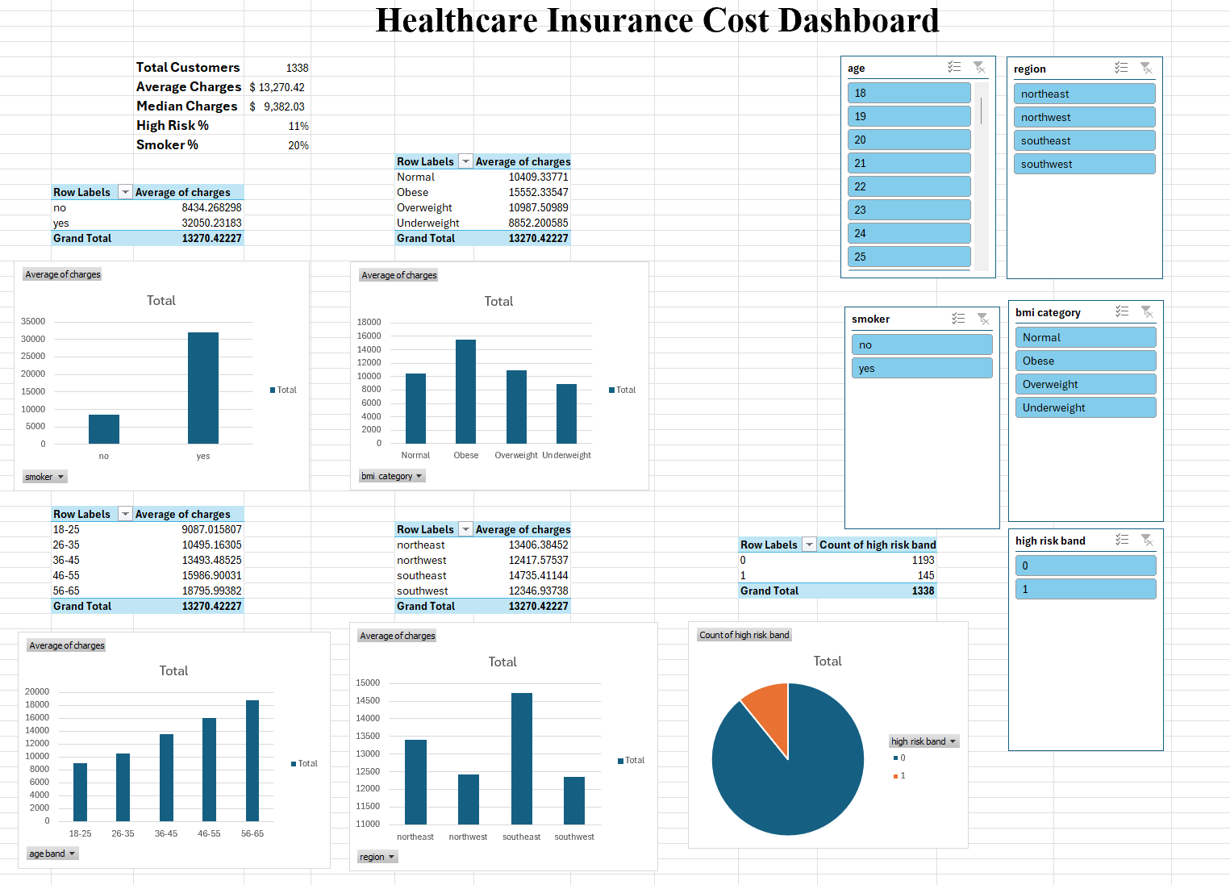

👩‍💻 Author
Amrutha Thalla
📧 thallaamrutha5@gmail.com
🔗 LinkedIn: https://www.linkedin.com/in/amrutha-varshini-thalla-3688a23a2
🔗 GitHub: https://github.com/amruthathalla

